Practical 6
Question:
Create a client-server application using Named Pipes (FIFOs). The client sends messages and the server processes and responds to them. Analyze FIFO behavior when multiple clients communicate simultaneously.
Code:
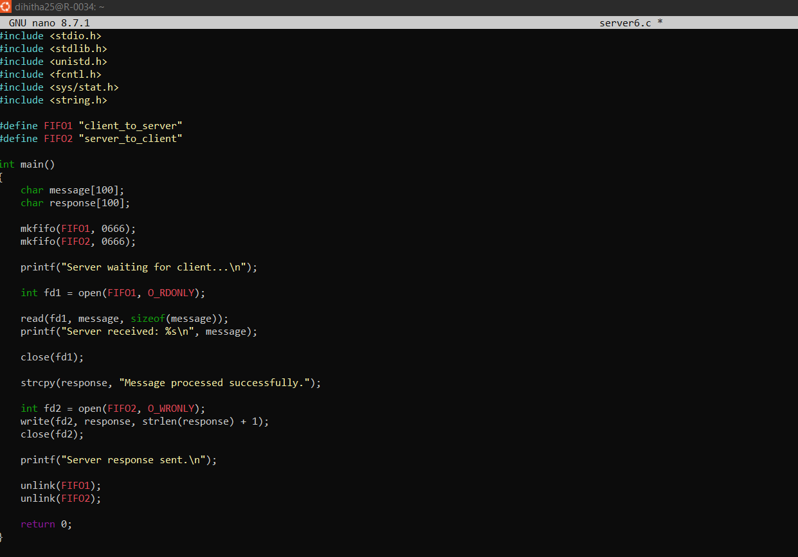
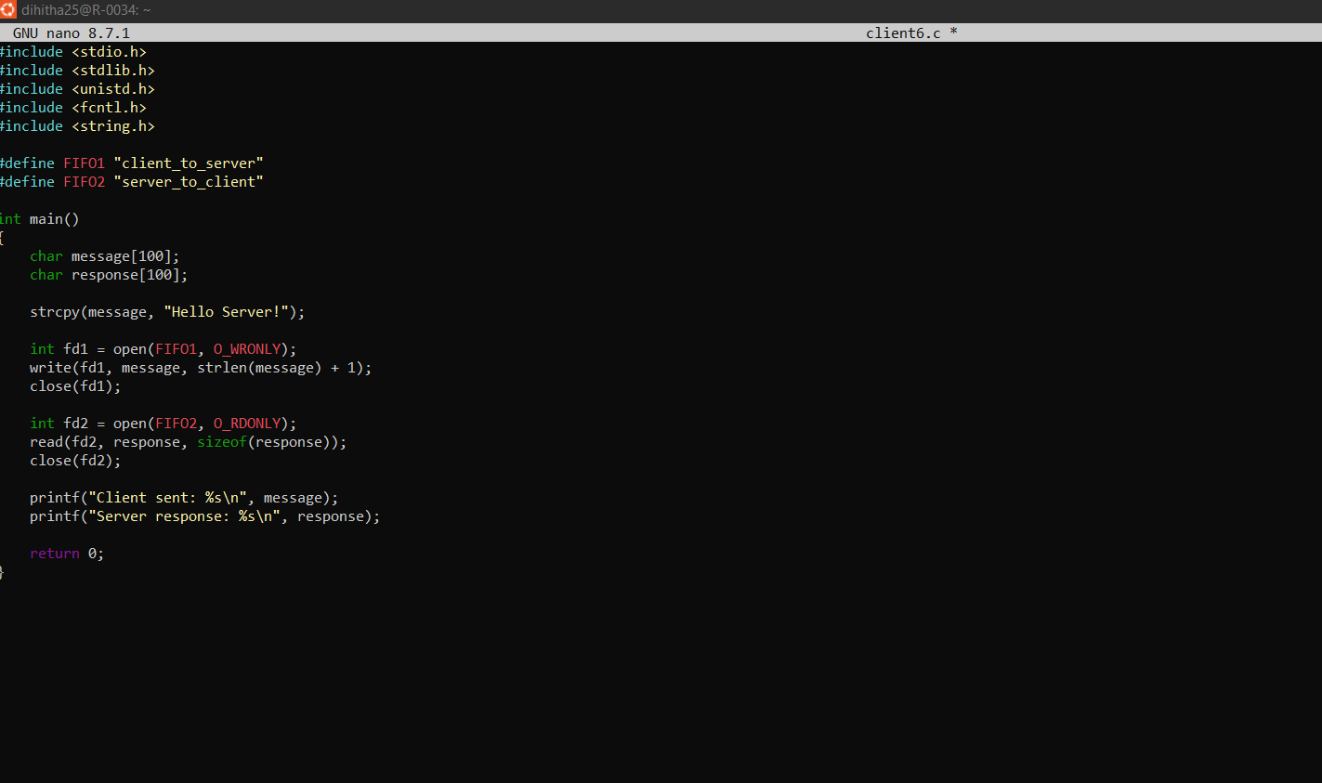
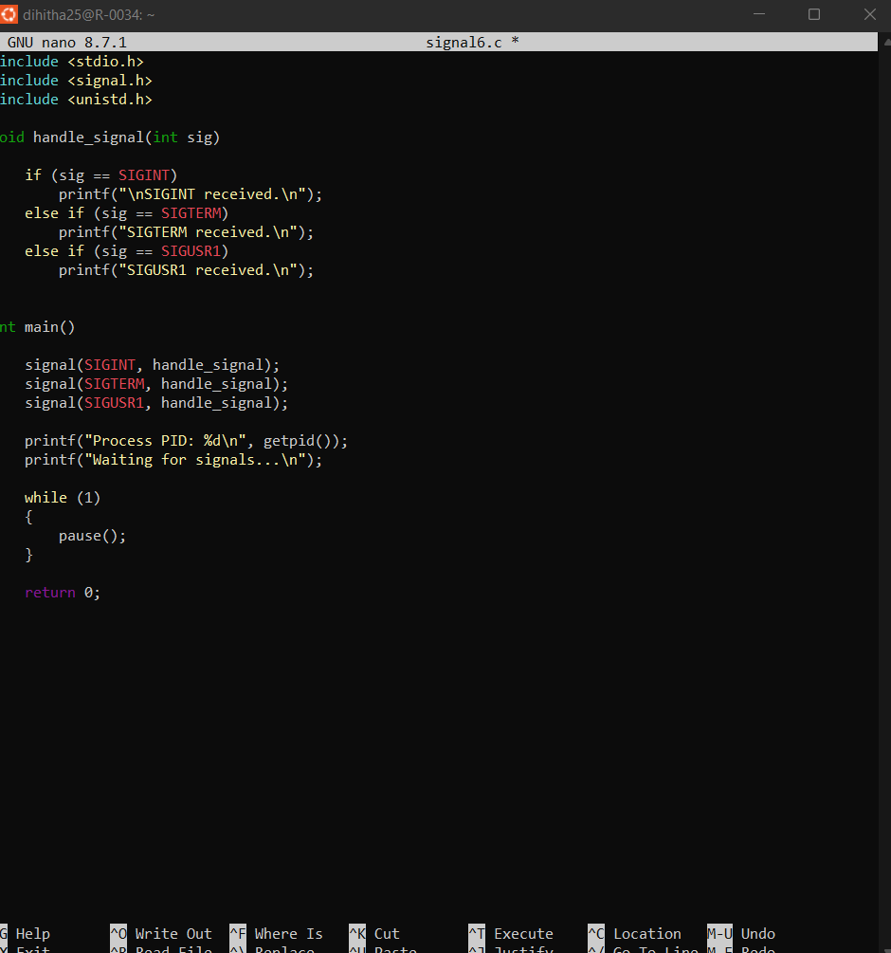
Output:
